Port Washington Teaching Artist Wins Grant
Posted by Adina Genn (Editor) , April 11, 2014 at 02:08 PM

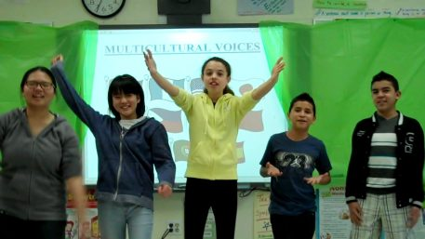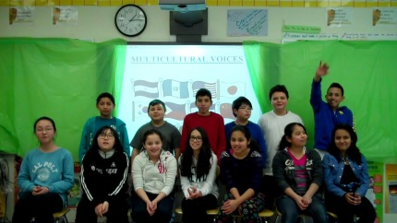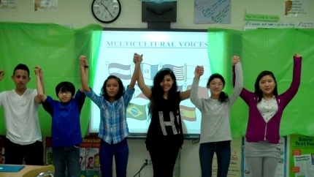
Children give a presentation in the Multicultural Voices – Multimedia Stories of Immigration

Expressive Elocution Teaching Artist Elise May, a Port Washington resident, has been awarded a 2014 Long Island Creative Curriculum Grant for the Arts for her program “Multicultural Voices – Multimedia Stories of Immigration.”
The program’s primary goal is to help Weber ESL students become as confident expressing themselves in English as in their own native language. The program uses interactive, theatrical storytelling workshops to empower students by helping them improve intelligibility and communication confidence while sharing stories of their cultural and immigration history. The culminating project will be a movie of the students’ stories.
This year’s program had 25 students from Japan, Spain, El Salvador, China, Korea, the Philippines, Nicaragua, Guatemala and Brazil. The program was developed with Weber’s ESL/ELL teachers Amy Booth, Helen Hsie and Debra Ravo.
The academic and social stress of being a middle school student can seem insurmountable. With the added pressures and challenges of learning a second language, students may become anxious, unwilling to participate and feel left out of much that school has to offer. By using theatrical techniques to help students creatively overcome their fears of performing in English and theatrical speech techniques to improve pronunciation, it is Ms. May’s hope to increase students’ comfort level with spoken English so they may have fun using language expressively. Enjoying performance in the program may lead to greater participation in the classroom and involvement in other school activities.
As an outgrowth of her Expressive Elocution program, Ms. May has been working with Weber’s ESL/ELL students since 2005 with the support of the Weber HSA, the Port Washington Education Foundation, the PWUFSD; Sheri Suzzan, Director of Creative Arts; Shirley Cepero, Director of ESL; Marilyn Rodahan, Weber Principal and the Weber ESL teachers.
Multicultural Voices is made possible with funds from the Decentralization Program, a regrant program of the New York State Council on the Arts with the support of Governor Andrew Cuomo and the New York State Legislature and is administered by The Huntington Arts Council, Inc.
May has taught theater programs in the North Shore, Garden City, Massapequa School districts as well as other districts in the metropolitan region.
Learn more about the program by visiting www.expressive-elocution.com.

